**CS311 Yoshii - HW2 Part 2 – Sorting Analysis (based on week4 - week 5)**

**===============================================================**

**DUE: Week 6 Tuesday at the beginning of the class**

**TOTAL: 36 points Your score is:**

**Your NAME:**  Justin Goulet

**Date Turned in:** 6 October 2015

----------------------------------------------------------------------------------------

**Purpose: To demonstrate your understanding of analyzing searching and sorting algorithms.**

------------------------------------------------------------------------------------------

1. **Review Questions [1 pt per question = 5pts] Your score is:**

**Type your answers here**

1. **Would you use Selection Sort or Insertion Sort? Why?**
   1. **Insertion Sort**
      1. Faster, but only in worse case scenario
2. **Rika-Chu Sort corrects one inversion per comparison.**

**What is its worst case number of comparisons? Why?**

1. **n^2**
2. **Why?**
   1. **[n(n-1)]/2**
3. **What is the advantage of using Merge Sort over Quick Sort?** 
   1. **Quick sort can get worse than nlogn (can be n^2) vs always nlogn**
4. **What is the disadvantage of using Merge Sort over Quick Sort?**
   1. **More memory is used**
5. **Why is Radix sort unrelated to the F(n) = O(nlogn) theorem?**
   1. **Uses no comparisons**

**B) Sort**

**230 123 324 10 23 56 (6 items)**

**using Insertion Sort and fill in the answers below.**

**[7pts] Your score:**

**Start with pos 2 for X index:**

**Which items were shifted? 123/230**

**How many element comparisons until X is deposited back? 1**

**The resulting list is? 123 230 324 10 23 56**

**Start with pos 3 for X index:**

**Which items were shifted? None**

**How many comparisons until X is deposited back? 1**

**The resulting list is? 123 230 324 10 23 56**

**Start with pos 4 for X index:**

**Which items were shifted? 123 230 324 10**

**How many comparisons until X is deposited back? 4**

**The resulting list is? 10 123 230 324 23 56**

**Start with pos 5 for X index:**

**Which items were shifted? 123 230 324 23**

**How many comparisons until X is deposited back? 4**

**The resulting list is? 10 23 123 230 324 56**

**Start with pos 6 for X index:**

**Which items were shifted? 123 230 324 56**

**How many comparisons until X is deposited back? 4**

**The final resulting sorted list is? 10 23 56 123 230 324**

**Q) Total number of comparisons was (add up the above):**

**14**

**Q) Give an example list for which you would have made the worst number of comparisons:**

**24, 18, 10, 5, 2, 1**

**C) Using the Merge Sort algorithm, sort [8pts] Your score:**

**8 5 6 3 9 2 1 7.**

**Fill in the []’s:**

1. **Break this up into: [8, 5, 6, 3] and [9, 2, 1, 7]**
2. **Break these up into: [8, 5] and [6, 3] [9, 2] and [1, 7]**
3. **Further Break these up into: [5] and [8] [3] and [6] || [2] and [9] [1] and [7]**

**Combine what and what? 5, 8**

**Produce what? 5, 8**

**How many element comparisons for this part? 1**

**Combine what and what? 5,8 and 3,6**

**Produce what? 3, 5, 6, 8**

**How many comparisons for this part? 3**

**Combine what and what? 3, 5, 6, 8 and 2,9**

**Produce what? 2, 3, 5, 6, 8, 9**

**How many comparisons? 5**

**Combine what and what? 2, 3, 5, 6, 8, 9 and 1,7**

**Produce what? 1, 2, 3, 5, 6, 7, 8, 9**

**How many comparisons? 7**

**Q) Total number of comparisons was? 16**

**D) Sort**

**231 123 324 100 230 560 (6 items)**

**using Radix Sort.**

**Hint: use 0-list, 1-list, 3-list, 4-list etc. [6pts] Your score:**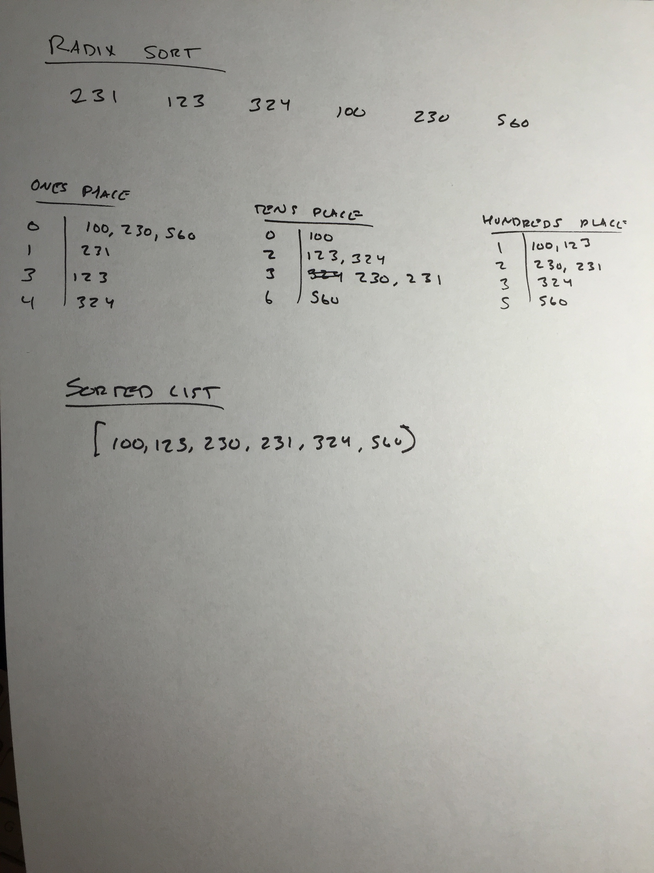

**E) Program Merge Sort’s Combine: [10 pts] Your score:**

**Using Notes-4B.doc code only the Procedure Combine of Merge Sort.**

**No ADT is needed. Just one source code file. – Run my solution program first.**

Void Combine will take 3 vectors as arguments: A, B and R.

Combine should work for any size vectors as long as the size of A and B are the same.

It will combine the elements of A and B into R to produce the sorted list R.

You should know how to find the size of a vector.

Display “comparison” every time an element-element comparison is done.

**Your main()**

1. Will declare three vectors L1, L2 and L3.
2. Will ask the user to type 3 integers in increasing order into L1.
3. Then ask the user to type 3 more integers in increasing order into L2.
4. Then it will call void Combine to combine L1 and L2 to produce L3 which is passed back by reference.
5. Display what is in L3.

**Required Test Cases: (Must test in this order)**

1. Combine 1 2 3 with 4 5 6
2. Combine 1 3 5 with 2 4 6
3. Combine 4 5 6 with 1 2 3

**Q) State of the program [2pts] No Program provided**

* **Does your program compile without errors? Yes because DNE**
  1. **List any bugs you are aware of, or state “No bugs”:No bugs**

**Submit these files:**

1. This assignment sheet with inserted answers.
2. Source code file of the program (with good comments).
3. Script or screen dump of the compilation and results.